Acoustics Lab Three Report
3/13/2025

Caleb Young
Department of Science and Engineering
University of Central Arkansas
Conway AR, United State of America
cyoung24@cub.uca.edu

Abstract:

This lab uses steel wire under tension to determine the speed of a pulse. Using this you can determine the mass per unit length of the wire. Experiment is derived from Dr. Slaton and a former UCA student.

Table of Contents:

- Introduction

- Theory

- Experimental Procedure

- Results

- Discussion

- Conclusions

- References

- Introduction:

The objective of this lab is to determine the speed of a pulse on a taunt wire and using that information determine its mass per unit length. Make sure that the methods support the equation for the wave speed on a stretched wire using the tension and mass per unit length.

Equipment List & Setup:

Item | Quantity
Guitar strings | 2
pickup | 1
sonometer | 1
Kg masses and hanger | assortment
Triple beam balance | 1
digital oscilloscope | 1
Stand, 90 degree connector and 3-finger clamp | 1
Wire cutters & meter stick | 1

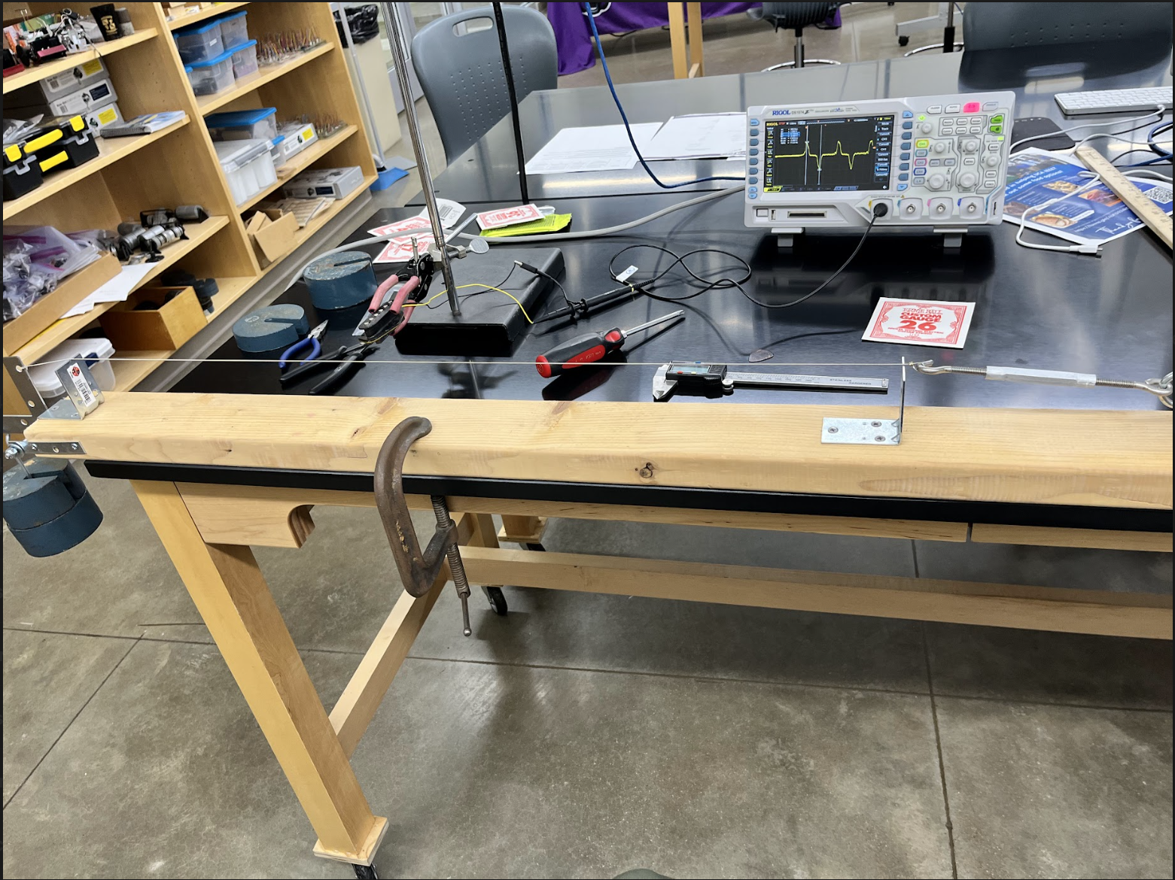

- Theory:

- Background:
After deriving the equation for the speed of a wave on a taunt string or wire of uniform mass per unit length, we find:
$$\sqrt{T/{ρ_{L}}}$$
where T is the tension in the string in N and ρL is the mass per unit length in kg/m. The wire will be plucked with a finger nail or guitar pick. The resulting pulse will propagate down the wire with speed, v, in m/s. The taunt wire can be plucked to generate a pulse that will travel down the wire to be detected by the electric guitar pickup coil. The pickup coil consists of tiny magnets (the metal cylinders) wrapped in many many coils of wire. A moving metal wire that disrupts the magnetic field lines will change the flux through the coil. Faraday’s Law states that a change in magnetic flux results in an induced voltage in the coil which we can detect with the oscilloscope.

- Experimental Procedure:

During the experiment, the potential difference generated when the pulse transverses the region of magnetic field will come in handy to determine the speed of the pulse on the wire for a given tension. When the pulse hits a bridge, it is inverted upon reflection and propagates back. This will cause a corresponding negative voltage generated in the coil which will be visible on the oscilloscope. Therefore, if you know the distance between the center of the coil and the bridge that caused the reflection then you can use the oscilloscope to measure the time between the pulse and its echo. The ratio of the total distance traveled and the total time gives the speed of the pulse.

Our goal is to verify that Equation 1 is correct. If we plot our experimental data as tension vs. velocity squared then the theory says the slope should be, ρL, the mass per unit length of the wire. We can experimentally and independently measure the mass per unit length by measuring the mass of a known length of the wire. A comparison of these two independent measures of ρL, with uncertainty! This will allow us to determine if Equation 1 is correct.

- Results:
Note: I made the mistake of physically writing down experiment results on paper. This caused me to waste a fair amount of time copying it into .csv files when the data should have just been recorded in them while carrying out the experiment. Please learn from this mistake of mine.

The image shown below are the on-paper resulting measurements made:
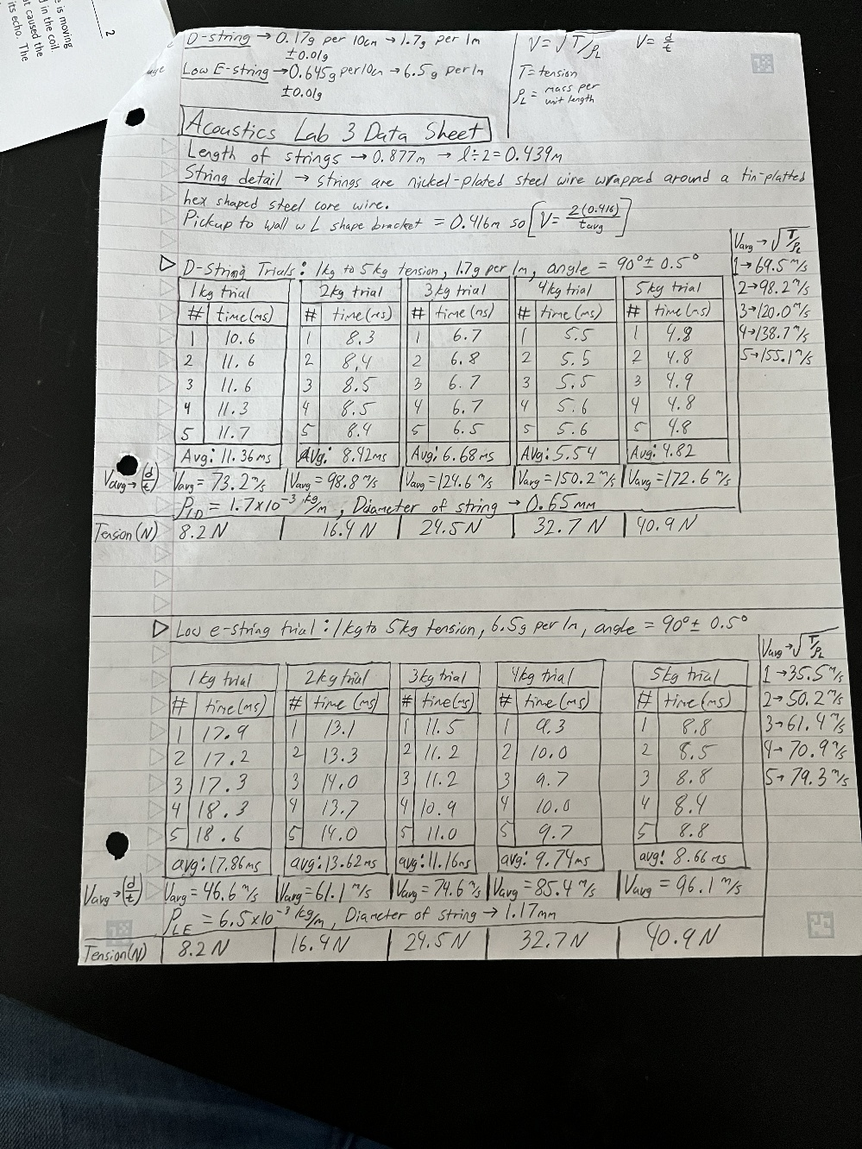

- Effective Mass & Stiffness Results:
After copying data to .csv files I was able to create a jupyter notebook in Visual Studio Code for the job of plotting data and performing calculations. I described my experiment to the CoPilot assistant in VSCode and used the Claude Sonnet 4.5 model for it. Once the experiment was stated clearly I gave the .csv files to it and it wrote the code to create detailed plots of my data. In addition to this, I also gave it the necessary theory and equations to use and it wrote the code to calculate the effective mass and spring constant for the speaker.

- The first piece of code for this did not plot. It only did calculations. Results/ output of this are shown below:
Speaker Without Box:
- Slope: 0.017220 ± 0.000169 s²/kg
- Intercept: 0.000615 s²
- R²: 0.999521
- Spring constant s: 2292.56 ± 22.44 N/m
- Effective mass m₀: 35.72 ± 1.79 g
- Resonance freq f₀: 40.32 Hz
Speaker in Box (No Stuffing):
- Slope: 0.003928 ± 0.000083 s²/kg
- Intercept: 0.000131 s²
- R²: 0.997769
- Spring constant s: 10050.73 ± 212.53 N/m
- Effective mass m₀: 33.46 ± 1.67 g
- Resonance freq f₀: 87.23 Hz
Speaker in Box (With Stuffing):
- Slope: 0.004142 ± 0.000124 s²/kg
- Intercept: 0.000143 s²
- R²: 0.995537
- Spring constant s: 9530.82 ± 285.37 N/m
- Effective mass m₀: 34.46 ± 1.72 g
- Resonance freq f₀: 83.71 Hz
- The plot of this graph came out nicely, but I could not figure out the error bars. The plot of added mass vs. the period squared data is shown below:

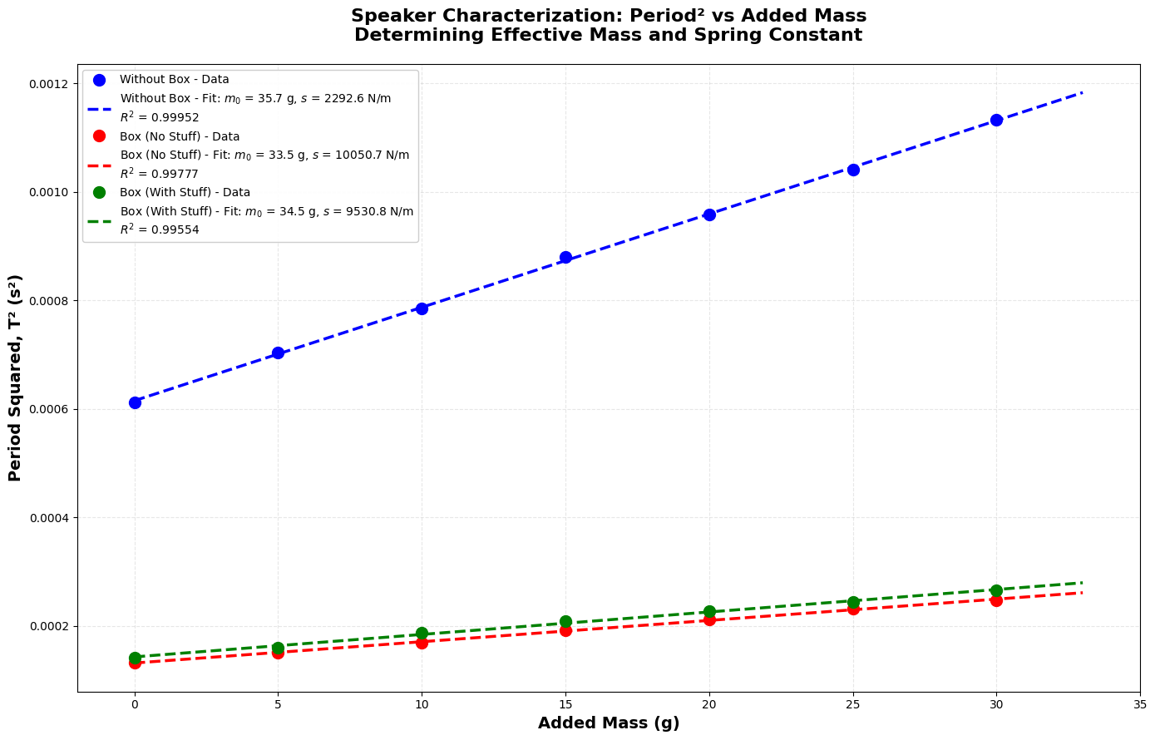

- Copilot did something very interesting without me explicitly stating to do so. It also calculated and displayed a comparison of configurations as well as a physical interpretation. These results are displayed below:

======================================================================
COMPARISON OF CONFIGURATIONS:
======================================================================
Configuration: f₀ (Hz) m₀ (g) s (N/m) R²

Speaker Without Box: 40.32 35.72 ± 1.79 2292.56 ± 22.44 0.999521

Speaker Box (No Stuffing): 87.23 33.46 ± 1.67 10050.73 ± 212.53 0.997769

Speaker Box (With Stuffing): 83.71 34.46 ± 1.72 9530.82 ± 285.37 0.995537
======================================================================

======================================================================
PHYSICAL INTERPRETATION:
======================================================================
• Speaker Without Box: f₀ = 40.3 Hz (lowest resonance)

• Speaker Box (No Stuffing): f₀ = 87.2 Hz (highest resonance)

• Speaker Box (With Stuffing): f₀ = 83.7 Hz (intermediate)

Box effect: Increases stiffness by 338.4%

Stuffing effect: Reduces stiffness by 5.2% vs empty box

- Mechanical Resistance Results:
Again, I had to copy the data from this experiment over to a .csv file. The results of this part are similar to the results above.

- The first code for this part of the experiment yielded just calculations like the last one. Results of this are displayed below:
=====================================================================
LAB 2: MECHANICAL RESISTANCE FROM FREE DECAY
=====================================================================
Free Decay Data:
n time (s) voltage (V) ln |V|
0.0 0.0016 -0.276 -1.29
0.5 0.0195 0.184 -1.69
1.0 0.0272 -0.164 -1.81
1.5 0.0400 0.108 -2.23
2.0 0.0527 -0.046 -2.34
2.5 0.0654 0.060 -2.81
3.0 0.0781 -0.058 -2.88
3.5 0.0908 0.036 -3.32
4.0 0.1030 -0.032 -3.44
=====================================================================
MECHANICAL RESISTANCE RESULTS:
=====================================================================
Linear fit: ln(|V|) = -1.269 - 21.71*t
R² (goodness of fit): 0.988962
Damping coefficient β: 21.71 ± 0.87 s⁻¹
Time constant τ: 46.06 ± 1.84 ms
Mechanical resistance R_m: 1.5512 ± 0.0619 kg/s
Quality factor Q: 5.83
Using m₀ = 35.72 g (from 'Without Box' measurement)
=====================================================================

- Copilot created two plots for these results. The first being the oscillations of free decay with voltage over time. The second being an analysis of this. See the images below:
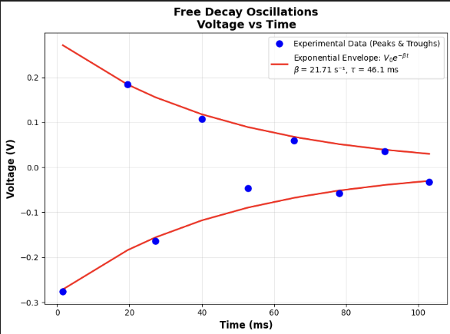
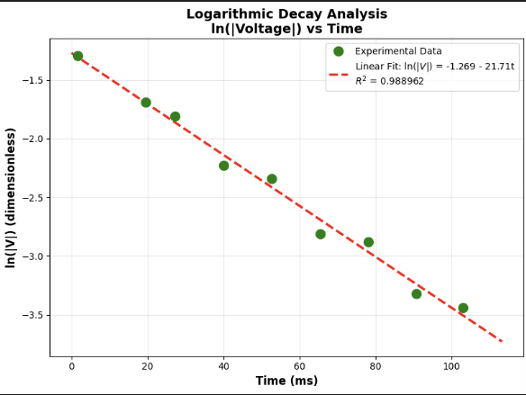
- Overall Results:
CoPilot impressed me with this code and analysis. I did not tell it to perform this, but it went above and beyond. The below information is some repeated results, but it helps to summarize the results all in one place. See the code output below:

LAB 2: COMPLETE SPEAKER CHARACTERIZATION SUMMARY

PART 1: Effective Mass and Spring Constant
----------------------------------------------------------------------
Without Box:
Resonance frequency f₀: 40.32 Hz
Effective mass m₀: 35.72 g
Spring constant s: 2292.56 N/m

Box (No Stuff):
Resonance frequency f₀: 87.23 Hz
Effective mass m₀: 33.46 g
Spring constant s: 10050.73 N/m

Box (With Stuff):
Resonance frequency f₀: 83.71 Hz
Effective mass m₀: 34.46 g
Spring constant s: 9530.82 N/m

----------------------------------------------------------------------------------------------------------------------------------
PART 2: Mechanical Damping (Without Box)
----------------------------------------------------------------------------------------------------------------------------------
Damping coefficient β: 21.71 s⁻¹
Mechanical resistance: 1.5512 kg/s
Time constant τ: 46.1 ms
Quality factor Q: 5.83

======================================================================
PHYSICAL INSIGHTS:
======================================================================
1. Box Effect on Resonance:
- Adding a box increases resonance from 40.3 Hz to 87.2 Hz
- This is due to air spring inside the box adding stiffness

2. Stuffing Effect:
- Stuffing reduces resonance to 83.7 Hz
- Absorbs sound energy, effectively softening the air spring

3. Damping:
- Time constant of 46.1 ms means amplitude decays to 37% in this time
- Q-factor of 5.8 indicates overdamped system

- Discussion:

- Effective Mass and Stiffness:
The results of this part of the lab were satisfactory to my standard. However, I believe I have much to learn on this subject. Studying electricity and magnetism dynamics at the same time as taking this acoustics class helps me to visualize what is going on in the speaker down to the level of electric and magnetic interactions. Combining this with the study of acoustics helps to understand the big picture of speakers overall. As was stated in the beginning of this report, “A speaker is a beautiful electromechanical system”.
This part of the experiment was not hard to complete and is a really fun way to gain understanding of the cross overs between electromagnetism and acoustics.

- Mechanical Resistance:
Again, the results of this part of the lab was satisfactory. After plenty of practice collecting data in the first part, using the o-scope became easy.

- AI-Usage:
The usage of CoPilot inside of VSCode is great. Parts of this lab in my opinion need to be done with your own personal knowledge and reasoning skills. It is important to do this during experimentation as understanding where human error occurs or could happen plays a huge role in experimentation in all areas of study. Now once you’ve collected good sufficient data and know where faults might lie, I believe it is totally reasonable to use AI in creating graphs and summarizing data. Make sure to review its results as I had to correct a few things in mine.

- Conclusions:

From the results of this experiment I see why speakers get put in boxes not only for protection, but also for the physical additions they add to the sound. Without a box the speaker has to perform more work to output a larger sound. It also helps with the oscillations of the speaker that would cause rattling. A higher resonance frequency will also help to draw out more of the bass sounds that are hard to hear around 40Hz. This will of course depend on the material, size, shape, and stuffing inside of the box.

The air inside of the box acts as a spring due to the oscillations of the speaker. This adds stiffness to the overall system. Now without stuffing its good, but adding stuffing helps to absorb any sound inside of the box that could mess with the sound quality. You could say the stuffing dampens the air spring.

The second part of this lab helps to dive deeper into the concepts above. The Q-factor of 5.8 indicates that the system is overdamped. This means that any extra sound or noise that would cause undesired sound quality is handled already by the speaker design. With the addition of the box and stuffing this effect is improved.

Overall, this was a fun lab and gives insights to things that I like to study in my free time. I love music and playing guitar and designing a system for myself is a goal I have for the future.

- References:

Note: I need help with proper referencing

[1] “Lab 2: Speaker Characterization”, Dr. Slaton Ph.D., 2026

[2] CoPilot in VSCode, Creating plots and calculations.

